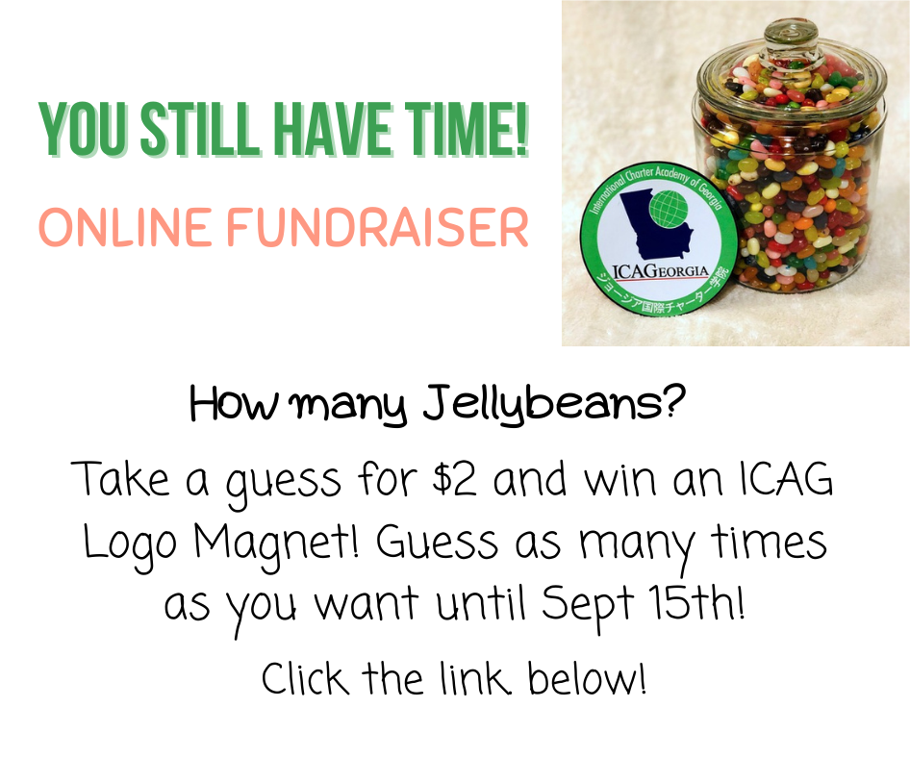
Guess How Many Jelly Beans HERE! Purchase Tickets to Magic Show HERE!

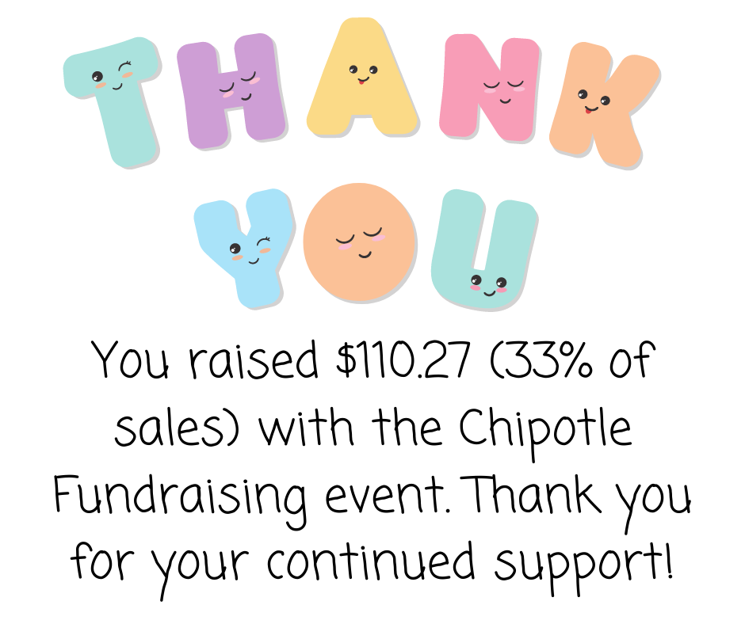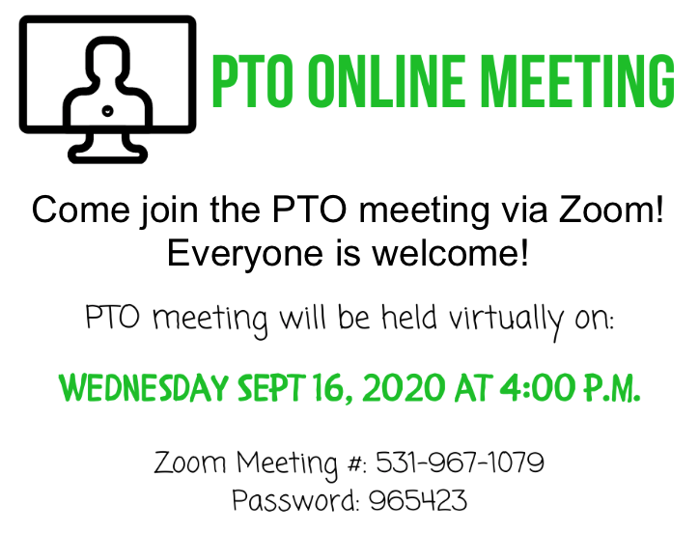

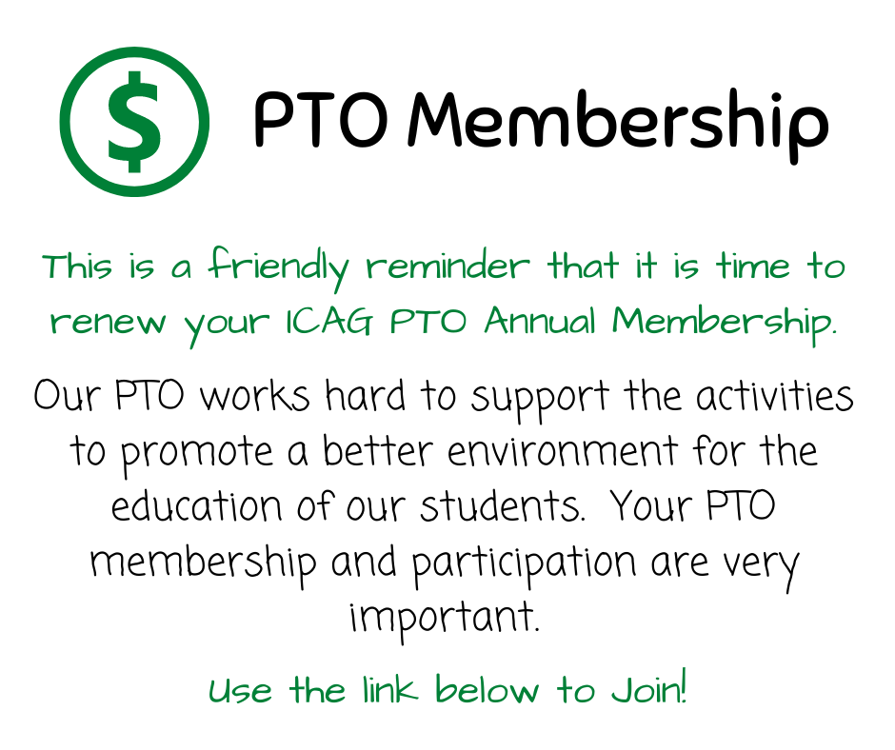

Renew Membership/ Join the PTO!
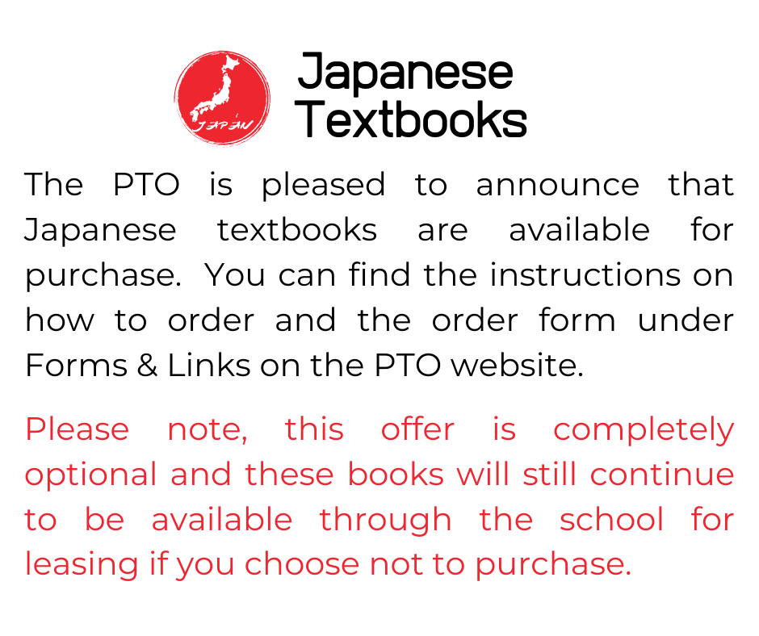
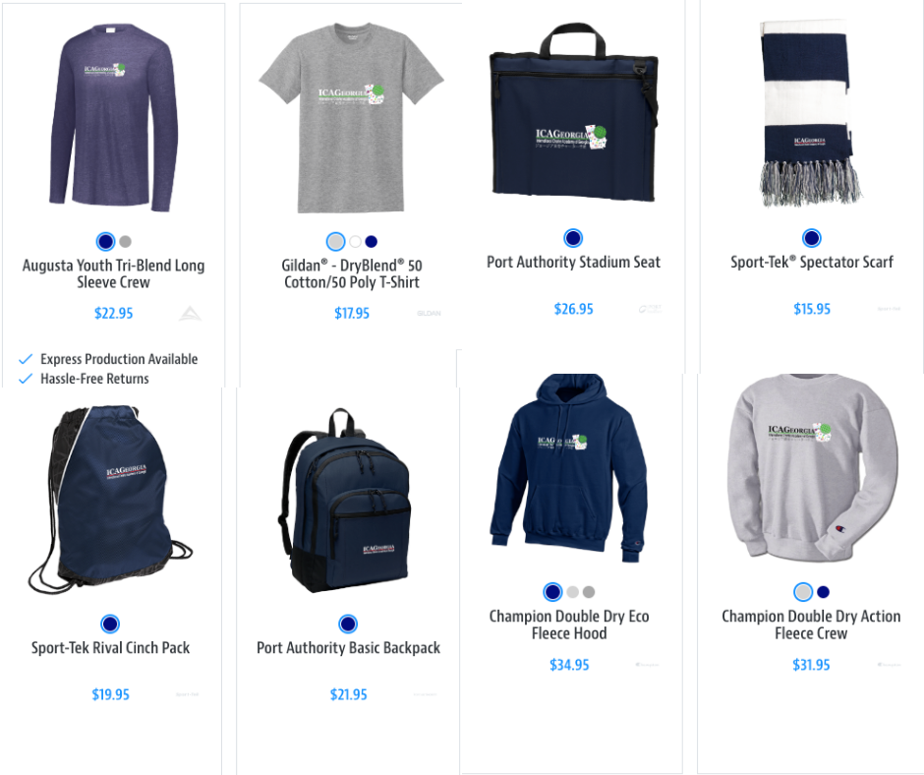

Japanese Textbooks Order Form More ICAG Logo Merchandise!

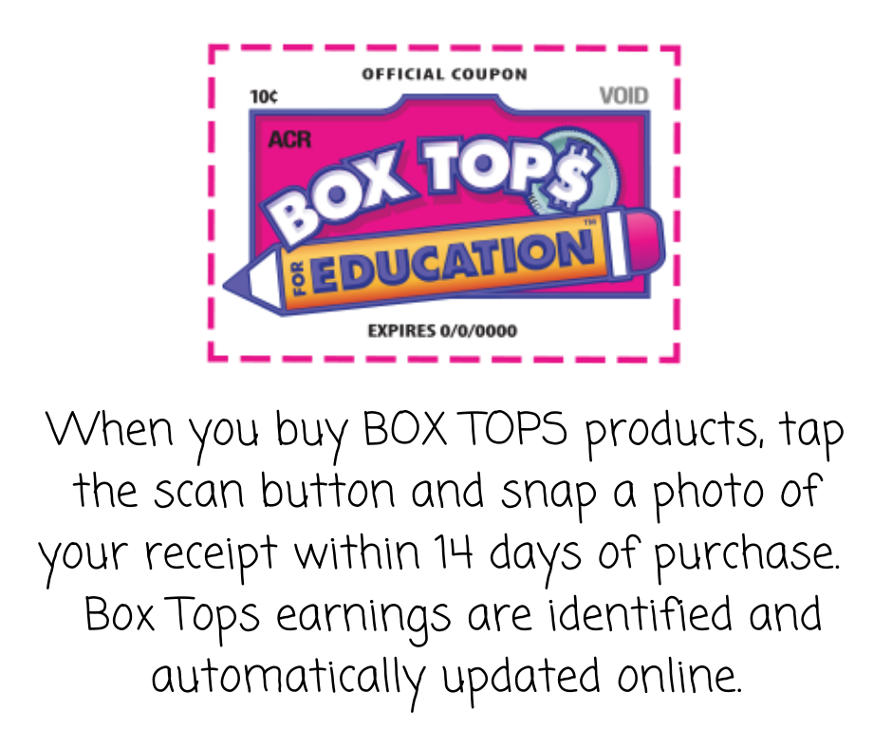  Download Box Tops app & sign up here!  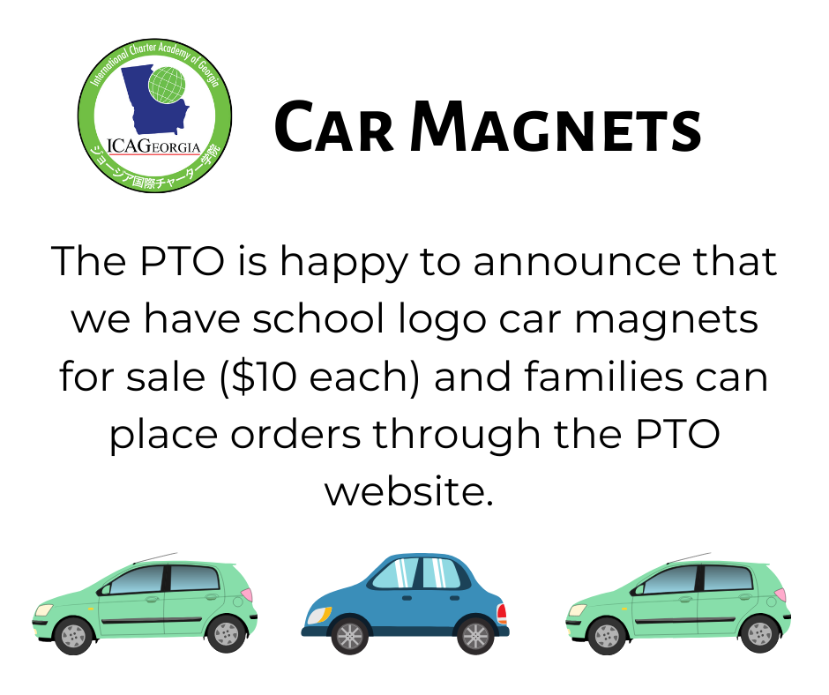  PTO Online Store | 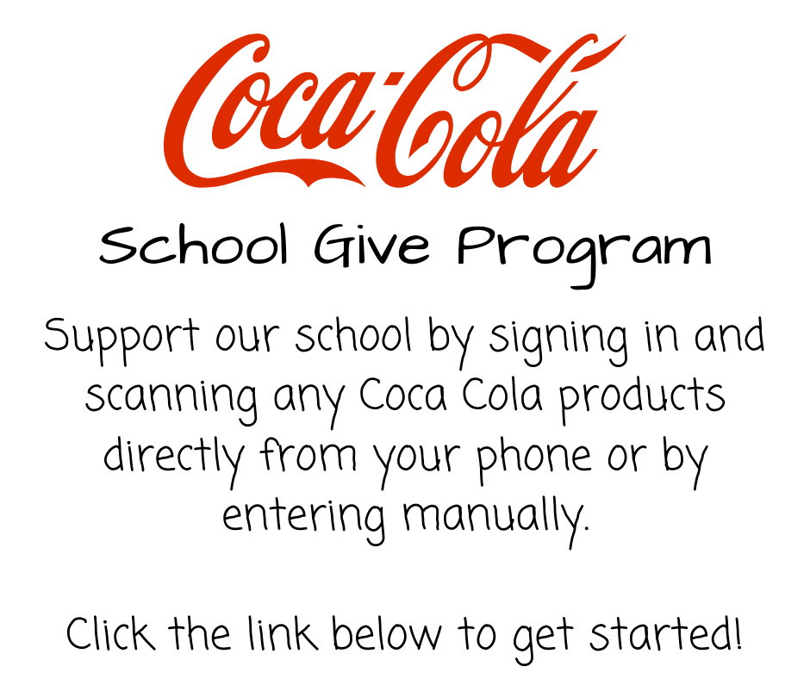  Start Donating with Coca Cola Give!  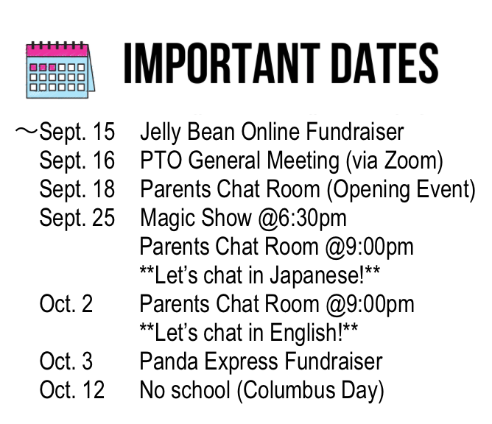
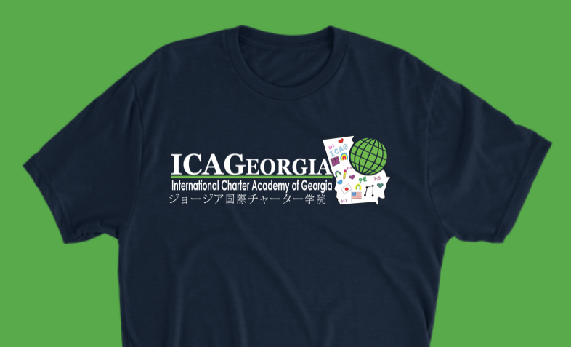
ICAG Spirit T-shirt | Don't forget to use Amazon Smile!
Students are allowed to wear the ICAG Spirit T-Shirt  on Fridays with jeans.  We now offer new color and more items!  T-Shirts can be purchased via the ICAG PTO website or by using the link below.  $3 from each sale is donated to ICAGeorgia!  https://teamlocker.squadlocker.com/#/lockers/international-charter-academy-of-georgia-275088?_k=q38hq7  (The vendor website is not optimized for Internet Explorer browser.) | Every time you shop, Amazon will give a percentage to ICAGeorgia. It's as simple as that.  NEW ON AMAZON!! You can now support ICAGeorgia on your phone! Set up AmazonSmile right in your Amazon account now!  Click here to Set it up now!
Parents make a difference in the ICAG PTO.
It's people that give this organization its strength and unity.
Thank you for reading, thank you for participating, and thank you for supporting the ICAG PTO.

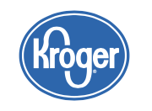
School Code: RD299 | Sign up and Select the School | Click the Link to Connect | Go to the website

